**Incredible levels of detail but once again, as with lit review, you are rewriting your entire dissertation. It needs to be much simpler and shorter based around simple criteria formatted e.g.**

**SUPERVISION**

**Date / time**

**Main issues discussed**

**Work shown**

**Questions asked; how questions were answered**

**Actions**

**WORK DONE**

**Here, it could be**

**Technical work (just a headline, not an explanation of the whole thing – that is in your dissertation)**

**Writing – which part of thesis**

**Issues and challenges**

**Each week only needs to be a page max and include evidence – screenshot of supervision; link to recording**

Actions for this week:

Continue completing the remaining energy measurements for the six baseline models.

Present this week’s experimental results to my supervisor.

Reflect on why rTsfNet achieves high accuracy on RealWorld but only moderate performance on LARa.

Ask my supervisor whether the solution to the gradient explosion problem can be written up in the dissertation.

Design a new model based on rTsfNet.

Consider whether additional state-of-the-art models are needed as a stretch goal.

Start drafting the literature review.

What did I do this week? Why should I did this?

1. Use an energy-proxy approach rather than professional laboratory measurements: run the models on a GPU in Google Colab, read GPU power and related statistics, and estimate the energy consumption of the remaining models.
2. Present to my supervisor the complete results of all six baseline models on the RealWorld dataset, as well as the corresponding estimated energy consumption of these six models.
3. Ask my supervisor about the following situation: I directly applied an existing model, without changing its architecture or hyperparameters, to train on another dataset, and gradient explosion occurred. If I can explain why the gradient explosion happened and how I resolved it, can this process be included and discussed in the dissertation?
4. Design a new model based on rTsfNet, prioritising a lightweight architecture.
5. Consider whether I still have sufficient time and energy to add one or two state-of-the-art models from the last two years as additional baselines.
6. Continue reflecting on why rTsfNet achieves high accuracy on RealWorld but only moderate performance on LARa.
7. Drawing on high-quality literature reviews in the human activity recognition field, start drafting (and have already drafted part of) my own literature review.

Why:

1. This is one of the most convenient proxy methods for estimating energy consumption, and it is widely accepted in journals and conference papers. At the same time, it can be fully implemented in Google Colab: using Python code, I can read the instantaneous GPU power and, combined with other model attributes such as bytes and FLOPs, estimate the energy consumed per inference. Unlike other energy-measurement approaches, this method does not require purchasing any additional hardware and is a common, well-accepted engineering practice.

2. In the past two weeks I have already presented the results of the six baseline models on the LARa dataset to my supervisor. If I now present the performance of these six models on the other dataset, my basic experimental work will be complete, and I can move on to more advanced experiments.

3. Resolving the gradient explosion problem already cost me a significant amount of time. If I am able to document why the gradient explosion occurred and how I fixed it in the dissertation, that would be extremely fortunate.

4. Since the foundational work—training and testing the six baseline models on both datasets—is now complete, and there is still almost one month before the dissertation submission deadline, I have the capacity to tackle more stretch goals.

5. At present, my entire experimental setup uses seven models in total, but only one of them is a state-of-the-art model from the last two years. If I develop a new model and compare it against only a single recent state-of-the-art baseline, the evidence may be less convincing. If conditions permit, it would be better to include 2–3 state-of-the-art models for comparison.

6. If rTsfNet indeed achieves high accuracy on RealWorld but only moderate performance on LARa, I can conduct an in-depth analysis of the reasons behind this discrepancy and present it in the dissertation as one of my findings and contributions. The original authors of rTsfNet did not evaluate their model on the LARa dataset. Moreover, whereas RealWorld focuses on daily-life activities, LARa targets warehouse and logistics operations. The differing performance of rTsfNet on two such distinct datasets can therefore be treated as a research gap worth investigating and as a source of originality in my work.

7. By starting the literature review early, I can give my supervisor more time to review it and provide revision suggestions. Since the literature review in my original proposal was quite weak, I need to put in extra effort this time.

Outcomes and findings:

1. I successfully completed the energy-proxy analysis for all six models: I provided an upper-bound estimate of the energy per inference (mJ/inf) and plotted accuracy–energy and accuracy–FLOPs Pareto frontiers. These are clearly presented as proxy estimates rather than true on-device measurements. I also fitted a linear energy model of the form

2. My supervisor asked whether I had a consolidated summary of the estimates. My response was: among this group of models, MiniROCKET delivers the best overall trade-off. Although it does not achieve the highest accuracy, it has a small model size, low latency, and the lowest estimated energy consumption, which are its main advantages.

3. My supervisor commented that if I have analysed why gradient explosion occurred and how I resolved it, then documenting this process in the dissertation would be a very good idea.

4. I successfully designed a lightweight variant of rTsfNet. Its accuracy is only about 3% lower than the official rTsfNet (0.7815 vs. 0.8139), but its model size (1.55 MB vs. 3.66 MB) and inference latency (59 ms vs. 440 ms) are substantially better. Moreover, my lightweight rTsfNet is not simply a parameter-reduced version of the original: I removed the most complex components that contributed least to performance and retained only the most important and useful modules.

5. I found that, on the RealWorld dataset and under the same accuracy metric as my experiments (LOSO Macro-F1), DeepConvContext is among the best-performing models and can be regarded as a state-of-the-art backbone. It is also relatively accurate and lightweight/fast. Although it is not as extremely efficient as MiniROCKET, it is still very suitable for me to reproduce given the limited project time—especially since I have no desire to repeat the experience of MultiROCKET, where a single fold took seven hours to train.

6. Based on my investigation, it is very unlikely that rTsfNet’s strong performance on RealWorld but only moderate performance on LARa is caused by my way of handling gradient explosion. In many journal and conference papers, it is common to see models that perform very well on one dataset but poorly on another. My hand-written implementation of the official rTsfNet is essentially aligned with the original paper. As a next step, I can test the best-performing RealWorld model, DeepConvContext, on the LARa dataset and observe the results. If DeepConvContext also performs only moderately on LARa, then the issue lies in the interaction between the model and the dataset—it may be that DeepConvContext is not well suited to LARa, or that LARa is simply a more challenging dataset.

7. Although I have been very busy with other experimental tasks, I still managed to write part of the literature review. The amount written is not large, but it represents a solid starting point.

Reflection:

1. In this round of energy estimation experiments, I successfully applied the proxy method to all six baseline models. To be safe, I should test the energy consumption of my newest baseline model, rTsfNet, as early as possible. rTsfNet is structurally much more complex than the previous six baselines, so the procedure for measuring its energy consumption may also be more complicated—not to mention that I am planning to add DeepConvContext as an additional state-of-the-art baseline.

2. For now, the summary I reported to my supervisor is that, among the six baseline models, MiniROCKET achieves the best overall trade-off between model size, latency, energy consumption, and accuracy. However, I have not yet measured rTsfNet, DeepConvContext, or the subsequent self-developed models, so it is too early to draw final conclusions. Moreover, if I want to design a new model, MiniROCKET is currently a very strong competitor: ideally, my new model should surpass MiniROCKET in at least some dimensions. My first thought is that it is probably unrealistic to beat MiniROCKET in model size, inference latency, and energy consumption, because MiniROCKET is currently extremely strong in these three aspects within the HAR community. But there is always a trade-off: MiniROCKET serves as a very fast and lightweight baseline with low energy cost, yet its accuracy is “good” rather than “excellent.” So for a future model, I could aim to design something that is not as light or fast as MiniROCKET, but achieves higher accuracy—preferably higher than both rTsfNet and DeepConvContext. If I succeed, that would be a major contribution and could even have the potential for publication.

3. It seems that encountering difficult problems and resolving them in a principled way is itself one of the key assessment points of an MSc project. When similar issues arise in the future, I do not need to worry too much about the time spent troubleshooting them, because if I ultimately solve the problem, the process can be written up as a contribution in the dissertation.

4. I have now successfully designed a lightweight version of rTsfNet. Its accuracy is decent but still lower than the official rTsfNet, and it is only on par with MiniROCKET. On RealWorld, MiniROCKET achieves a LOSO Macro F1 of 0.7879, while my lightweight rTsfNet reaches 0.7815. This is already a contribution, but given that I still have sufficient time, I can continue attempting to design new models, ideally pushing LOSO Macro F1 beyond 0.8.

5. DeepConvContext is very suitable for me to reproduce in all respects. However, I suddenly had an idea: what if I combine the strengths of rTsfNet and DeepConvContext to design a new model? rTsfNet excels at rotation-robust encoding within each window, while DeepConvContext is strong at modelling long-range cross-window context. For example, I could use rTsfNet as the “within-window encoder” and then attach the “cross-window LSTM” component from DeepConvContext. I can also integrate ideas from other strong models, such as modern Transformers; TST, which I have already used, is part of the Transformer family. I feel that if I want to develop a model that clearly outperforms existing ones, I should start from the best recent models and refine them—just as Newton said, “If I have seen further, it is by standing on the shoulders of giants.”

6. From my investigation, the reason why rTsfNet performs well on RealWorld but only moderately on LARa is mainly the difficulty of the LARa dataset, especially given that I use only a single IMU placement at the right wrist. “LARa MbientLab right wrist” corresponds to “fine-grained picking/packing actions in logistics with a single wrist IMU,” which is widely regarded as a challenging scenario, and I only use one sensor location. The official baseline tCNN, when used for HAR on LARa-MbientLab, reports a mean F1 of only about 0.53 and an accuracy of around 0.68, and this is already considered one of the state-of-the-art baselines.

By contrast, for RealWorld I use a single waist placement, whereas for LARa I use only the right wrist; the information content is completely different. The waist is almost the “centre of mass” of the body’s motion:

* Walking/running: periodic, large-amplitude movement that is very clear.

* Going up/down stairs: vertical patterns are extremely distinct.

* Sitting/standing/lying: gravity direction plus low-frequency posture changes are enough to separate them.

In the right wrist (LARa experiments), wrist signals in logistics tasks have several typical issues:

* Many segments of “standing still + small-range hand operations”: different activities show little difference at the torso level; only subtle variations in hand movement/rotation patterns.

* Frequent rotations and posture changes: lifting boxes, reaching for shelves, placing items in boxes lead to large changes in wrist Euler angles/quaternions.

* For some activities, the key discriminative factor is “holding an object or not,” or “moving toward or away from the shelf,” and such information is very weak or even invisible in a single right-wrist IMU.

Seen in this light, my earlier method for resolving gradient explosion was not the root cause. My self-developed lightweight rTsfNet does not suffer from gradient explosion on LARa, yet it still shows the same pattern of high accuracy on RealWorld and only moderate accuracy on LARa (approximately 0.78 vs 0.42). The reason it avoids gradient explosion is that, compared with the official rTsfNet, I removed some of the most complex modules that contributed little to performance.

7. The experiments are quite demanding, so I do not have much time for the literature review, but I will try to write a little each day. Sometimes, after some time has passed, tasks that initially seemed difficult start to feel easy—that is because I have been practising continuously in the background, even if the daily amount of work was small.

Have I finished last week’s action? What percentage?If not, how to improve?

Completion rate: 80%

What remains is to train and test DeepConvContext on the RealWorld and LARa datasets, and to design a new model that combines the strengths of rTsfNet, DeepConvContext, Transformers, and possibly other high-performing architectures.

Actions for next week:

* Continue writing the literature review.

* Train and test DeepConvContext on the RealWorld and LARa datasets.

* Design a new model that combines the strengths of rTsfNet, DeepConvContext, Transformers, and possibly other models.

* Evaluate all current models along four dimensions: accuracy, model size, inference latency, and energy consumption.

Email correspondence with my supervisor Halloran:

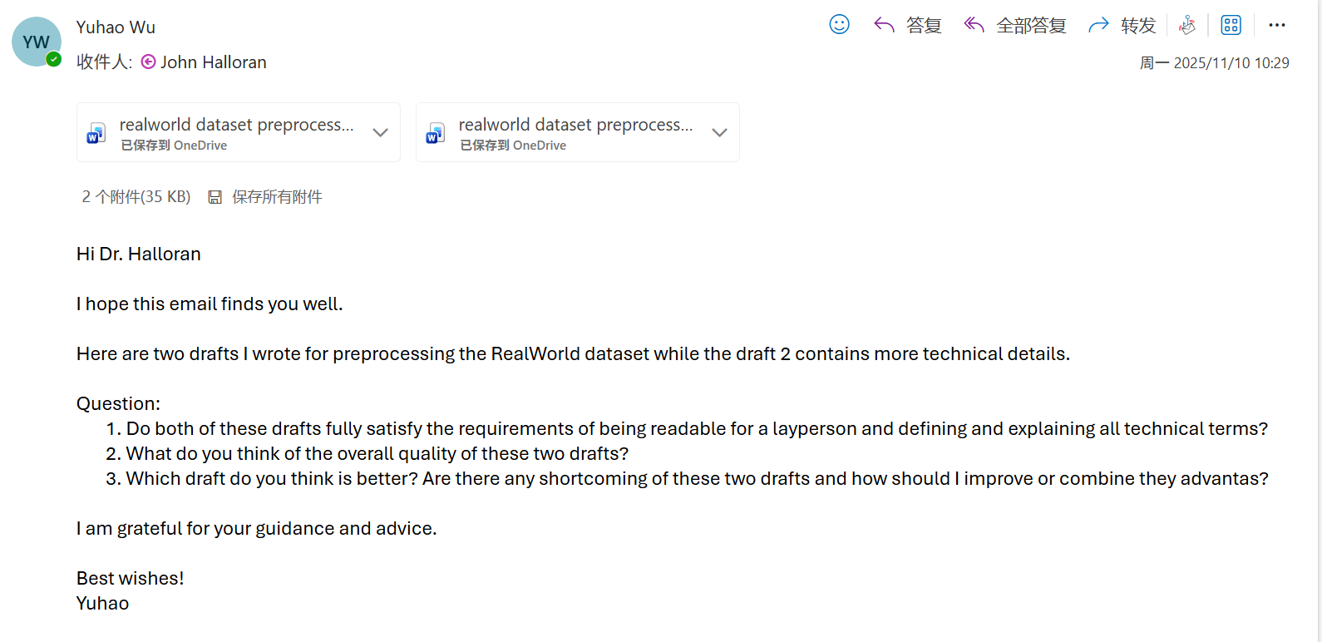

My supervisor was too busy to reply to the email, so I asked him directly during the meeting.

Meeting part:

I presented to my supervisor Halloran the performance of KNN, Random Forest, MiniROCKET, MultiROCKET, and TST on the RealWorld dataset. I also showed him a comparative analysis of the estimated energy consumption for the six models KNN, Random Forest, InceptionTime, MiniROCKET, MultiROCKET, and TST.

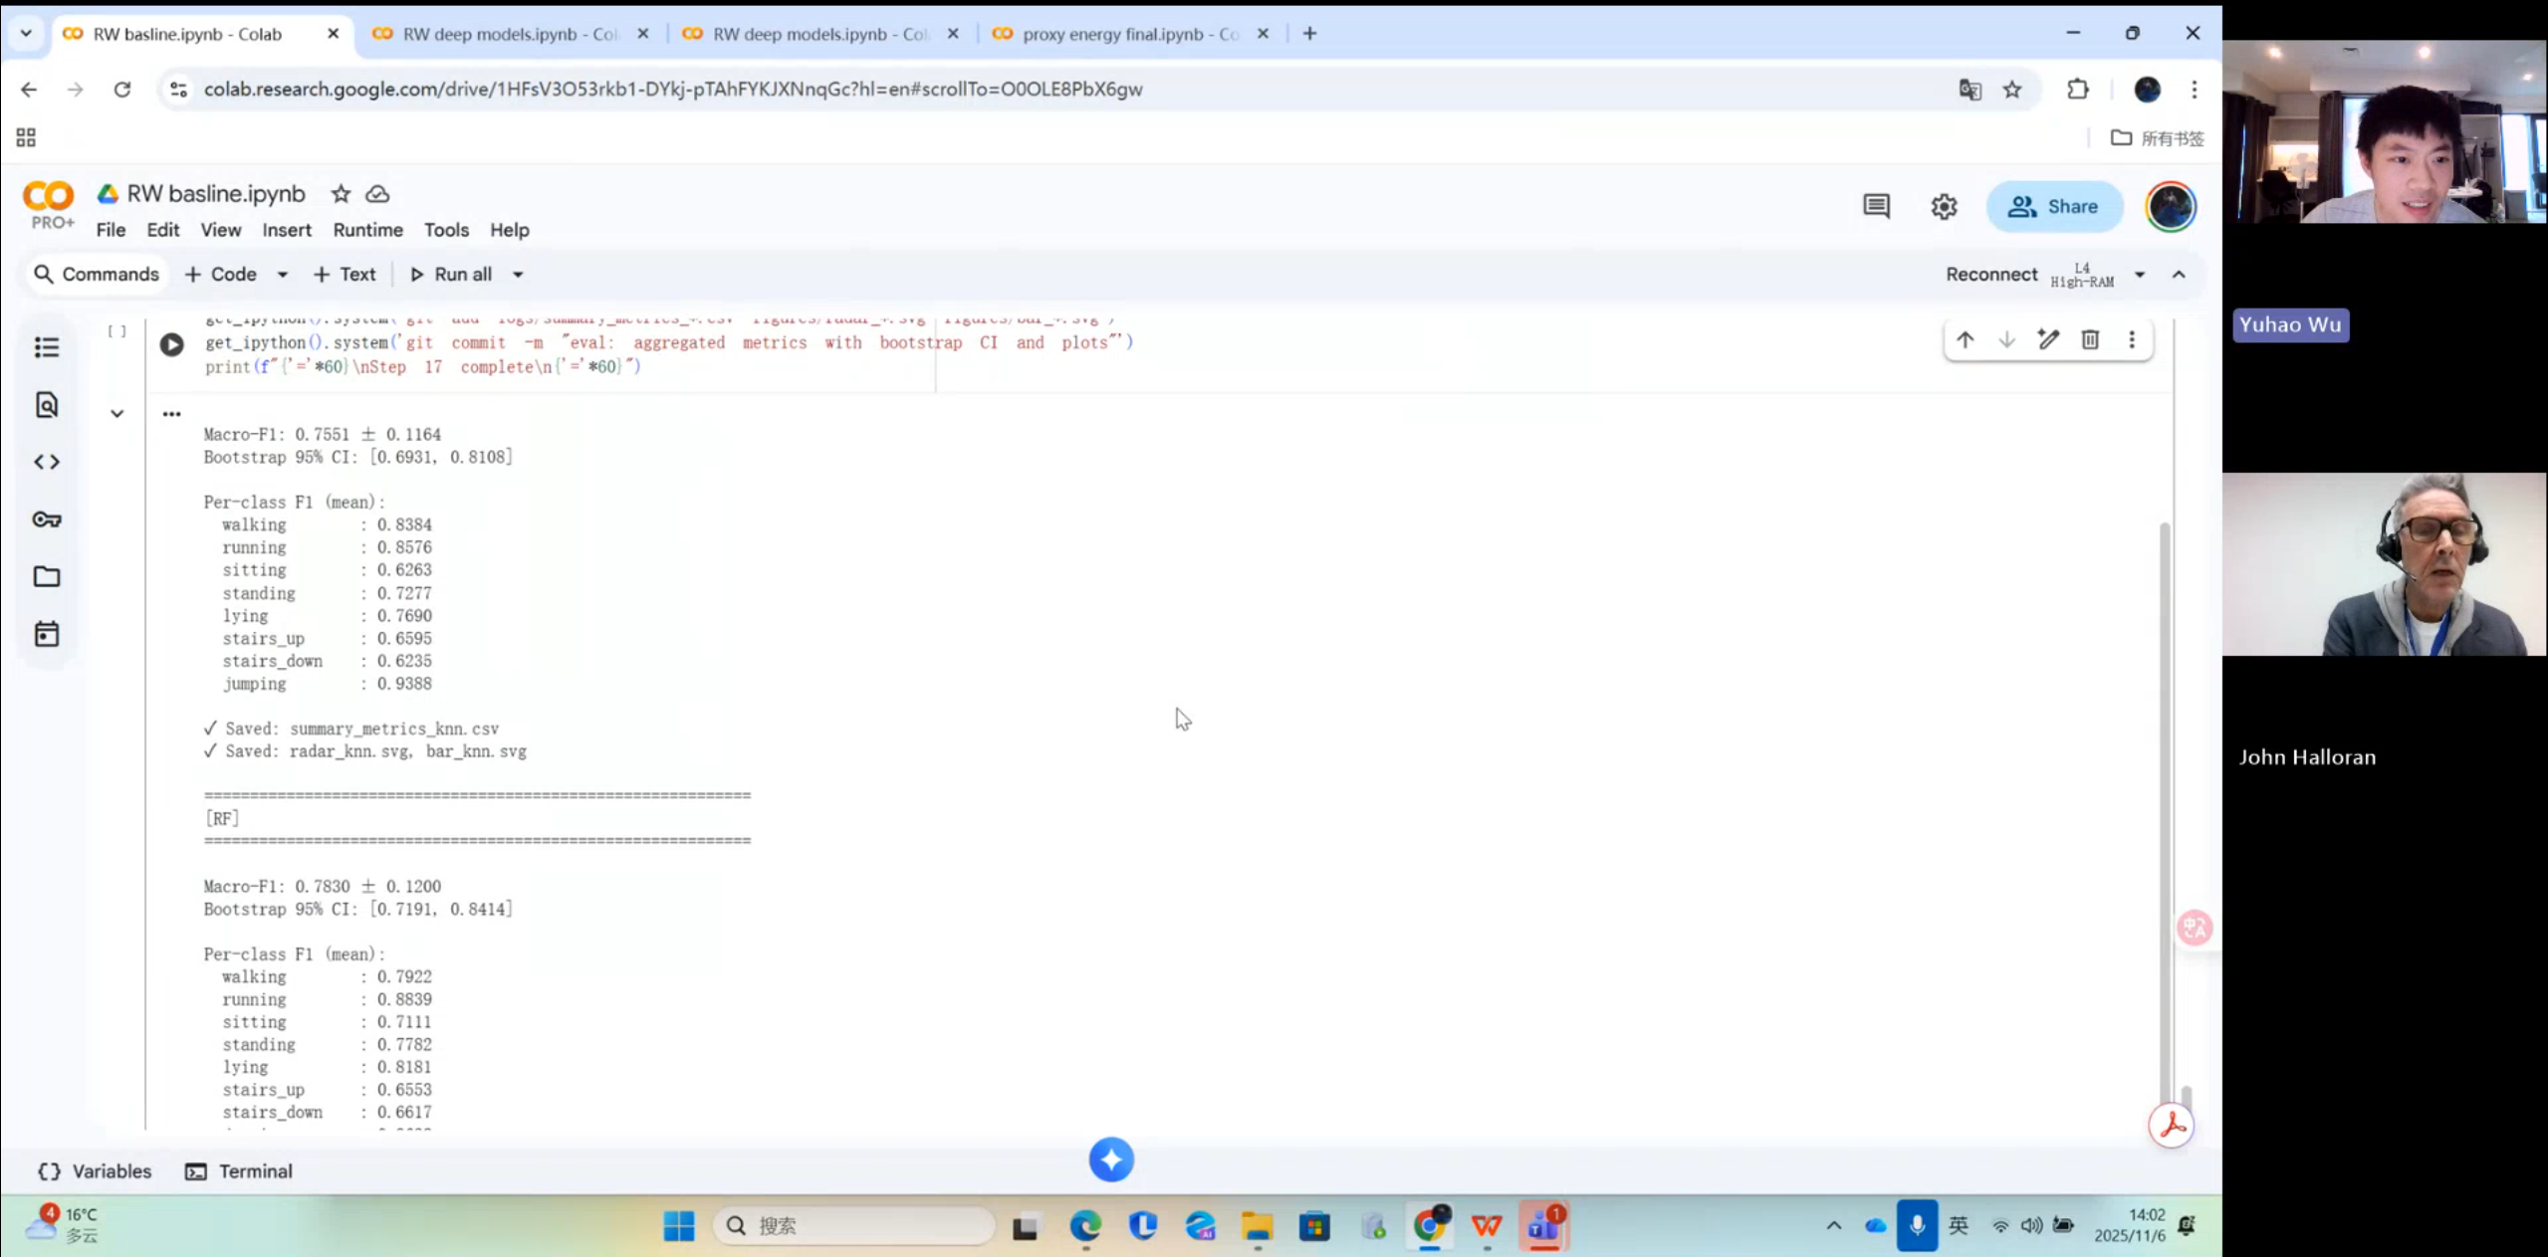

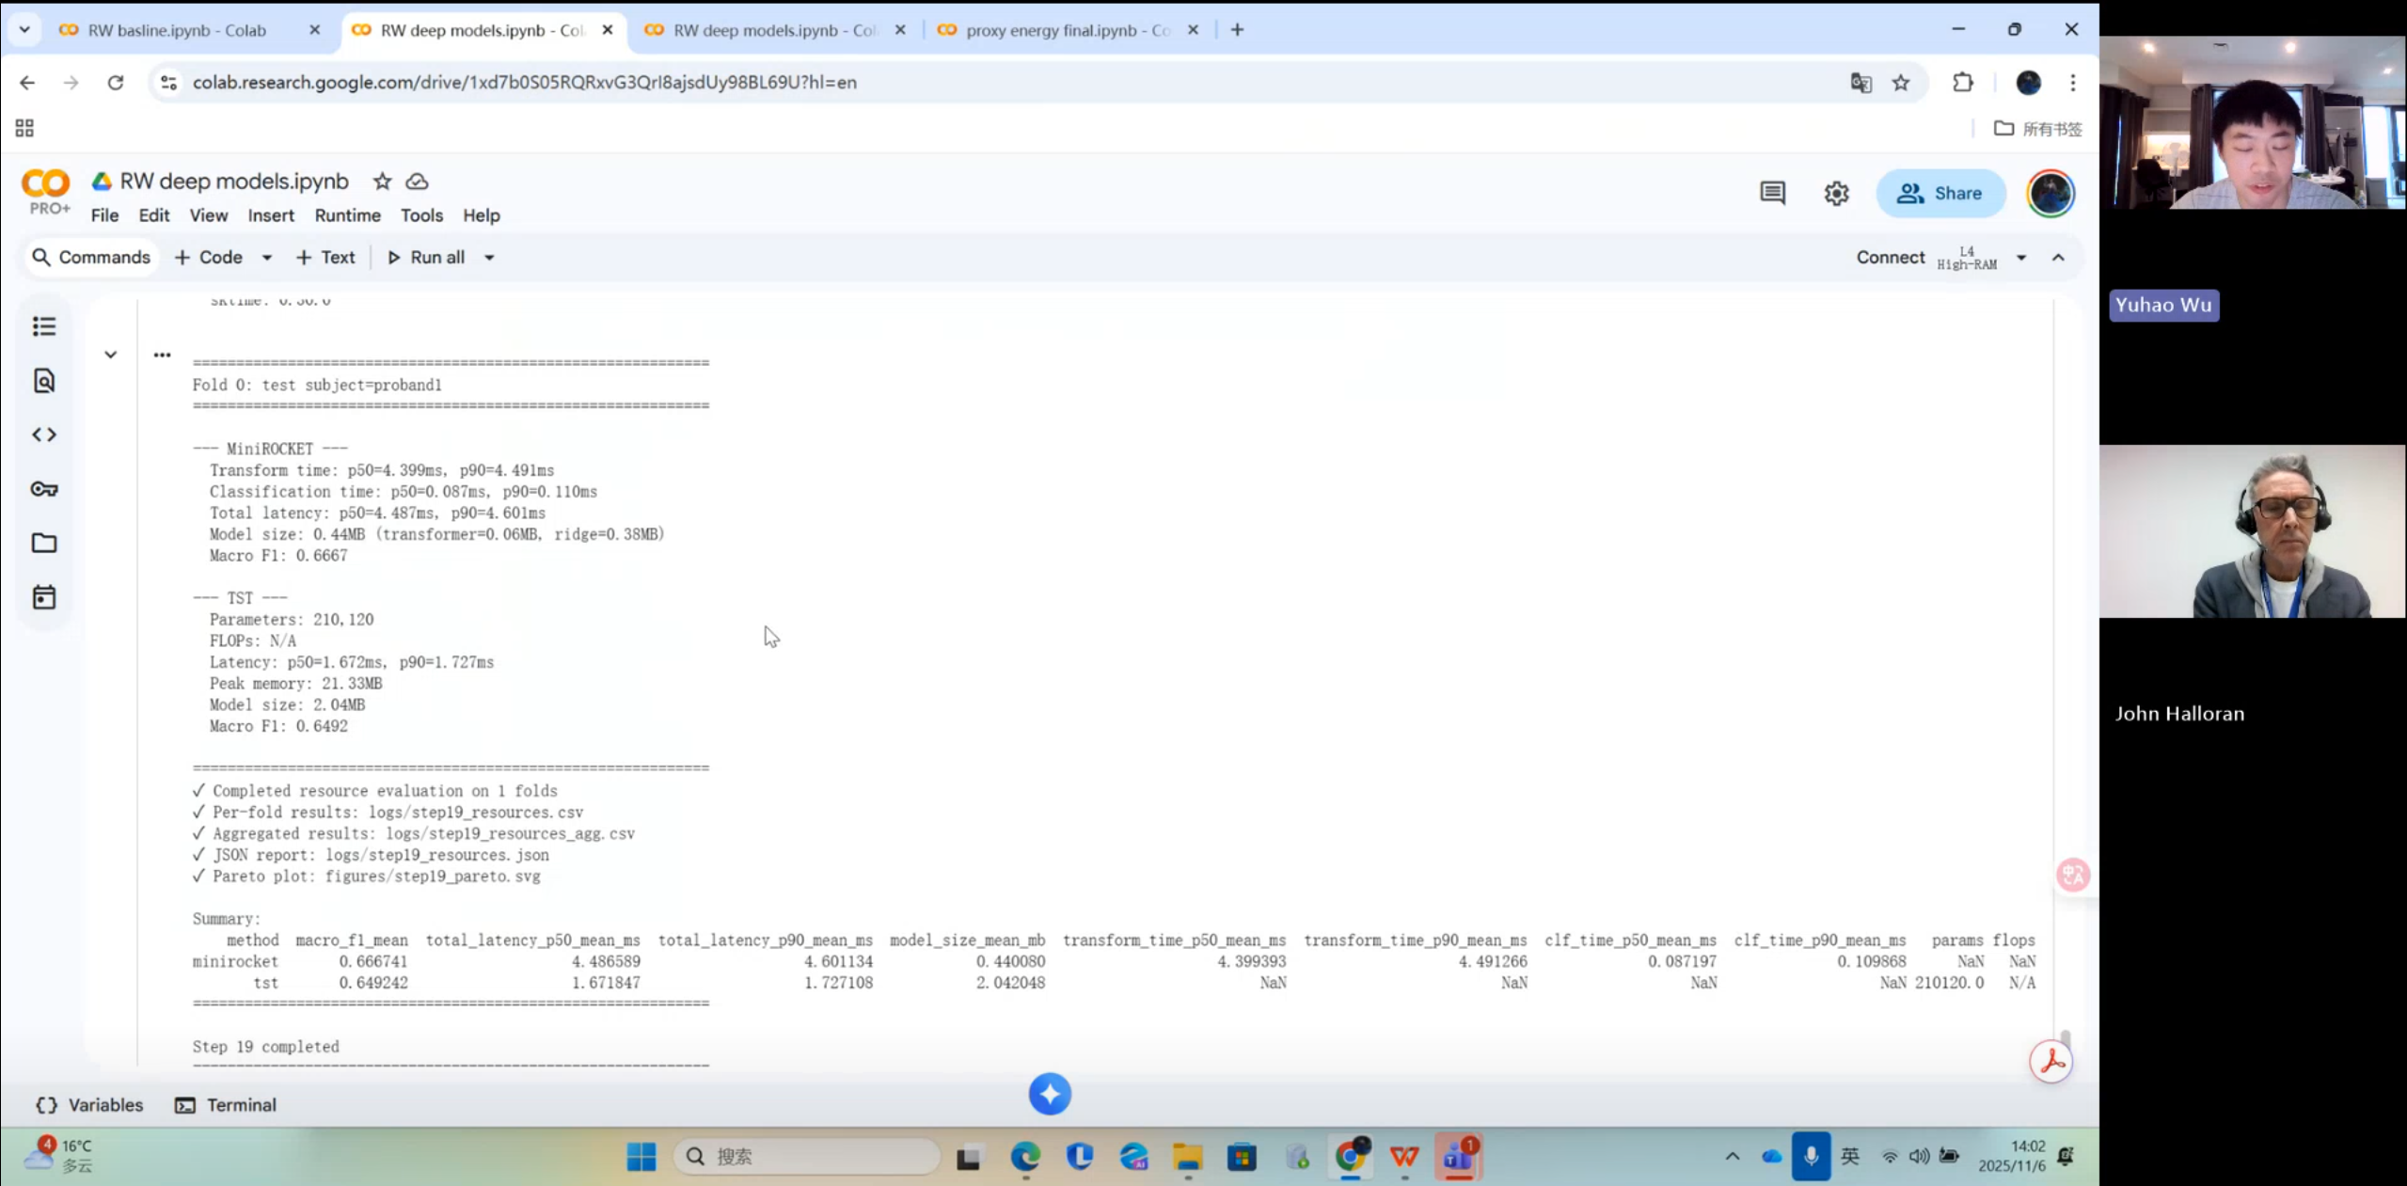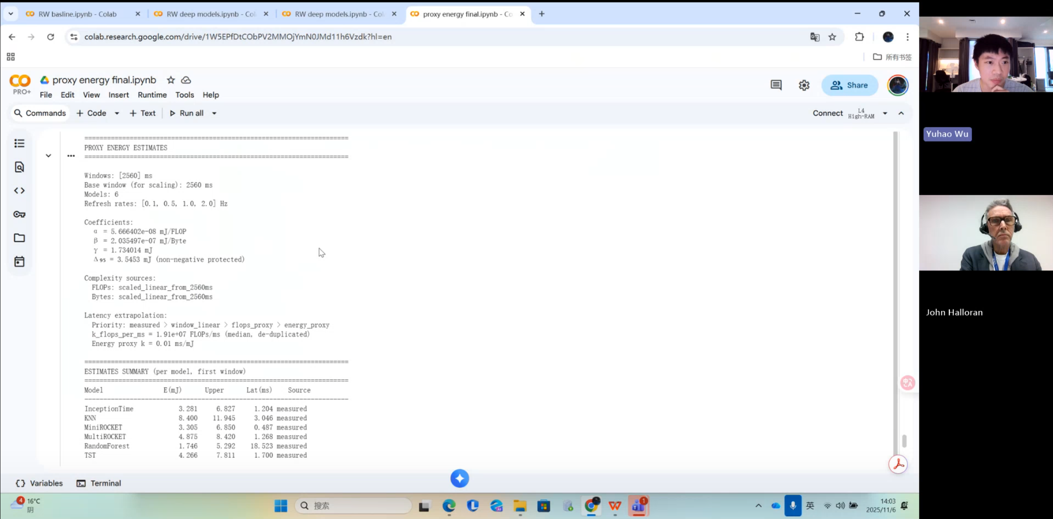

Me:

In this progress report I’ve done and presented a lot of experiments. First, I trained KNN on the RealWorld HAR dataset, then Random Forest and InceptionTime. I also trained MiniROCKET and the Time Series Transformer (TST). I tried MiniROCKET as well, but it uses a lot of GPU memory. I applied several acceleration tricks for training and testing, but it was still often very slow. So I was planning to exclude this model from the experiments in my dissertation. I also estimated the approximate energy consumption of the six models.

(Additional note: in fact, I did not completely exclude MiniROCKET—what I excluded was fully training all 15 folds of MiniROCKET on the RealWorld dataset. I have already fully trained MiniROCKET on the LARa dataset, and I have trained one fold on the RealWorld dataset. I simply forgot to explain this clearly to my supervisor.)

Supervisor Halloran:

Right, so you have some kind of consolidated set of estimates?

Me:

My conclusion is: among this group of models, MiniROCKET has the best overall performance trade-off. Although its accuracy is not the highest, it has a small model size, low latency, and the lowest energy consumption, which are its key advantages.

Supervisor Halloran:

Very good. I remember you showed me the beginning of your write-up earlier—the piece of writing/report. At the start I saw a document with your experimental write-up. Could you show that to me again?

So I then showed my supervisor Halloran my entire experimental workflow, and at the end of the document I asked him a question.

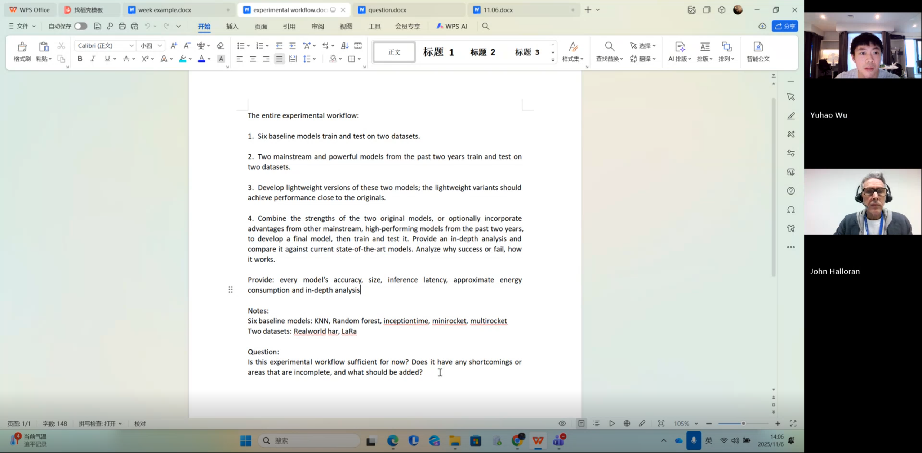



Me:

I have basically completed all the experiments. The next step is to do some model lightweighting and research on self-developed models.

Supervisor Halloran:

Good, very good. Right, OK. Give me the accuracy for each model — all 6 baselines. So that means you’ve finished the baseline stage. The question is: is this experimental pipeline sufficient at this point? Your goal was to establish a baseline using existing models. That’s good, and you’ve completed that part. The next stage of the research is to see how you can combine the models in some way, correct?

Me:

Yes.

Supervisor Halloran:

So the baselines are done, and the next step is model combination. That’s the most interesting part. I think right now you should first make the baseline performance very clear. Which models are you planning to remove? You’re going to discard some models, right? And then later you will combine the ones that remain. But there is a risk here: if you delete certain models, the question is whether one model might actually be improved when combined with another. Your worst result is Random Forest, right? I feel it performs the worst. But if you combine Random Forest with another model and integrate them in some way, might its performance improve? If so, that would be a very interesting finding. Even if it’s still not the best overall, it would still be meaningful — it would show that we can improve that model by integrating it with others. So I don’t think you should eliminate any model too early. You should explore different possibilities.

There is another question: if, after you’ve done all this research, the results do not improve over the baseline, what will you say then? If there is no improvement at all, what will be the conclusion of your study? Tell me, how would you answer that?

Me:

I would conduct an in-depth analysis to identify the reasons and explain why that particular model combination did not lead to any improvement. I would look at each sub-module in the combined model, identify which parts contribute positively and which parts drag performance down, and provide corresponding explanations.

Supervisor Halloran:

Yes, I agree. But remember, even if the research does not produce the results you hoped for, it is still a valuable outcome. Negative results are also useful, right? Because you can tell other researchers that there is no need, no rationale, and no benefit in doing it this way. That conclusion itself is important. It is a useful and significant finding. So even if there is no improvement over the baseline, it is still worth reporting, understood? What I mean is, don’t worry too much. Research is like exploration — we often don’t know what we will encounter. You see, even if we don’t get the ideal positive results, it doesn’t mean the research is bad, right? Because you can still tell others, “These are the results, and we have shown that trying to integrate these models does not bring any benefit,” correct? So what are you planning to do next?

Me:

I plan to combine their respective strengths, rather than just focusing on the baseline models as they are. I think that by integrating the strengths of popular contemporary models (or similar architectures), it may be possible to achieve better results.

Supervisor Halloran:

OK, no problem.

Me:

Can I include these examples in my weekly project progress documents for the project process?

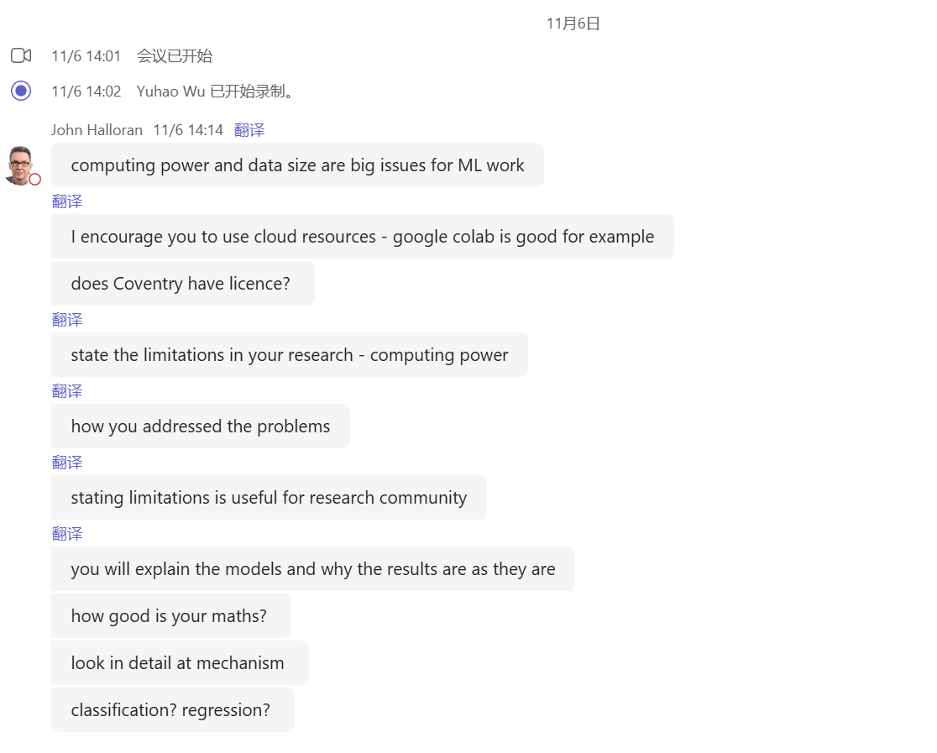

Supervisor Halloran:

Let me first take a look at what you wrote for Week 1. In the Machine Learning module, did you use Google Colab? That’s one way of getting more compute power; it’s an option. But I understand your point. One of the difficulties in machine learning is the scale of the data and the computation speed — that’s often a challenge. I think you can present this as a limitation of your study, because you are still a student, right? As for us (the department), I’m not entirely sure whether we have a Colab license; I imagine we do. But you can use Colab if you wish. What exactly are you using at the moment? What is your current computing environment/infrastructure for the machine learning experiments?

Me:

Sorry, could you repeat that?

Supervisor Halloran:

I’ll put this in the chat, because it’s important. What I want to talk about is the issue of computing power. Yes, so compute and data scale are the two big problems in machine learning work. If you’re only using an ordinary laptop, and you’re facing a large dataset and machine learning models, it just won’t work — you might have to run things for many days, or they may never finish. So I suggest you use cloud resources. The simplest option is Google Colab. There are, of course, other options. The obvious question is whether Coventry University has licences for these services.

Me:

Yes, we do. In my first semester, the lecturers recommended that we use Google Colab, and everyone could use it.

Supervisor Halloran:

That means we do indeed have a licence. Good, then use it. Use Colab if you find it helpful. But the important thing is that all measurements/evaluations must be carried out in the same computing environment, right? That is extremely important. Very good. There is another point: you need to clearly describe the limitations in your study, especially the limitations in terms of computational resources.

Me:

For example, specifying which GPU I’m using, and related details?

Supervisor Halloran:

Yes, that’s a very good idea. You should explain the limitations and how you addressed them. Let me emphasise again: because this is research, it is always valuable to understand these issues, and researchers should clearly describe the limitations of their work. This does not mean you will get a lower mark; on the contrary, explaining limitations is very useful for the academic community. Are you going to turn these supervision meetings into written notes?

Me:

Yes, I am.

Supervisor Halloran:

Good, excellent. And will you also translate some of this into Chinese?

Me:

Sometimes I do. If I’m worried that I might miss something or I’m not fully sure I understood, I translate it into Chinese.

Supervisor Halloran:

Good, that’s fine. So, the next question is: what are you planning to do in the coming week?

Me:

There is a relatively popular model from this year called DeepConvContext.

Supervisor Halloran:

So you mean you’re going to try more models, right?

Me:

I only plan to add this one as the final baseline model. Because I think, rather than trying lots more new models, it’s more important to do deeper analysis — for example, to understand how these models actually work and how I solve problems, instead of blindly running many experiments.

Supervisor Halloran:

I see. So you mean you will explain these models and why they produce the results they do.

Me:

Yes.

Supervisor Halloran:

Good, that’s very good. One common issue in machine learning student projects is that many students do not really explain the models. Often they simply say “this model is more accurate than that one,” but that’s not interesting. We need to know “why.” Why is one model more accurate? Why are some metrics better for certain models? If you can clearly explain these “whys,” that is excellent. The problem is that this often involves mathematics, right? How is your maths background?

Me:

Not very strong.

Supervisor Halloran:

Because explaining machine learning models often requires some mathematics. Well, I’m not a mathematician either — in many cases you can explain models at a higher level rather than purely through maths. But I still think you need to explain the algorithms and the machine learning models. For example, when you talk about a neural network, you should explain the network structure and how the data is processed. In other words, you need to go into the mechanistic details of the model. You also need to clearly identify the problem type: is it classification or regression? What kind of task is the model actually solving? And there’s another one… I’ve forgotten — there are usually three classic types of machine learning problems: classification, regression, and…

Me:

I’ve forgotten as well.

Supervisor Halloran:

Good research “explains” rather than merely “describes.” Of course, you do need description in research, especially for the results, but you also have to explain “why.” That’s the major difference between a pass-level project and a distinction-level project. Truly excellent projects explain why they get the results they do. It sounds like your plan for next week is good, very good. Do you have any other questions?

Me:

Yes — the document I showed you earlier. Is it appropriate if I write that kind of content into my weekly project progress logs and then include it as a link in the dissertation?

Supervisor Halloran:

Yes, that’s absolutely fine. Any other questions?

Then I asked supervisor Halloran three questions.

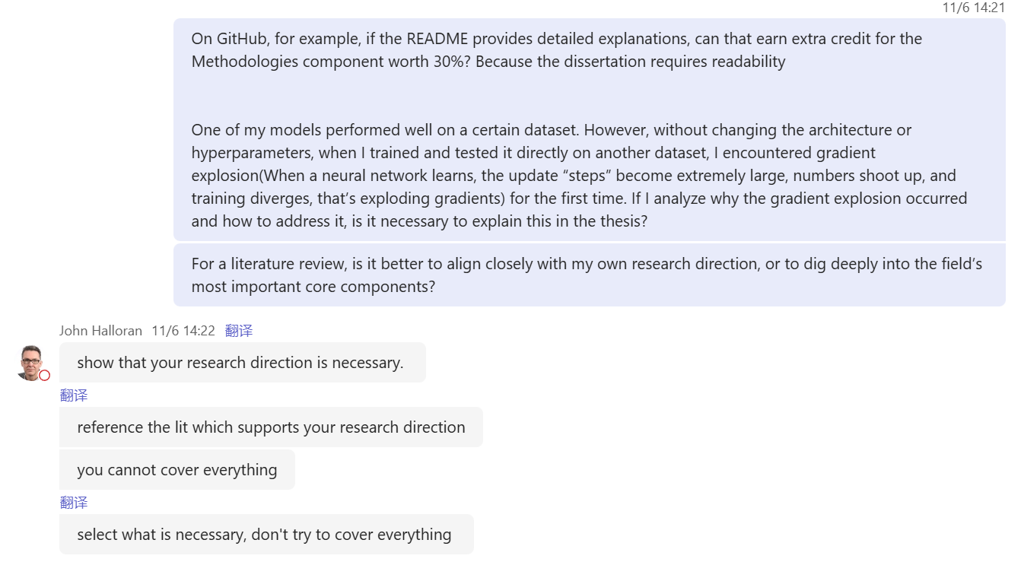

Supervisor Halloran’s answer to the first question:

Yes, you can. A well-documented GitHub project is definitely something that can earn you extra credit.

Supervisor Halloran’s answer to the second question:

If you analyse why the gradient explosion occurred and how you resolved it, is it necessary to explain this in the dissertation? Yes, that’s a good idea.

Supervisor Halloran’s answer to the third question:

Regarding the literature review: is it better to keep it tightly aligned with your research direction? Should you avoid trying to cover every major core area in the field in depth? That’s a very good question. What you need to do is demonstrate that your chosen research direction is justified. Therefore, your literature review needs to cite the works that support your research direction. You only need to focus on the most important core issues in the field, to the extent that they influence your research direction. It’s impossible to cover everything, and “trying to cover everything” is a common mistake in research. Right. You need to choose a narrow path, a narrow slice of the machine learning world, and connect it closely to your research question. The key is selection. It’s not about putting everything in, but about choosing what is necessary and not trying to cover it all.

My other piece of advice is: start writing as soon as possible, including the literature review and the write-up of your experiments. That’s about all I wanted to say on this. Show me your writing so I can give you feedback. You can email me the manuscript or send me a link and I’ll read it. We don’t necessarily have to wait and discuss it in a supervision meeting — I can look at it any time.

Me:

Okay, I think that’s fine. I’ve more or less completed the whole experimental pipeline, so I can start writing now, for example the project process and related sections.

Key points from what supervisor John Halloran has said (re-summary):

1. Experiments and research direction

* Current experimental pipeline is validated: the workflow you presented is feasible and solid.

* Baselines are complete: you already have 6 baseline models; you should report the accuracy of each and first give a systematic account of “baseline performance.”

* Next step: after the baselines, work on model combination/ensemble methods — this is the more research-valuable part.

* On discarding models: he initially asked which models you plan to drop, but clearly reminded you not to eliminate models too early; you should explore different combinations.

* Weak models can still be useful: even the worst baseline, such as Random Forest, may improve when integrated with other models — this alone can be an interesting research finding.

* Negative results are also important: if there is no improvement over the baselines, the conclusion is still valuable (e.g. “integrating these models brings no benefit”); research is exploratory, so you do not need to worry excessively about results that are not ideal.

2. Explainability and theoretical depth

* Strong projects “explain” rather than merely “describe”: do not just state which model is more accurate, but also explain why a given model performs better and why its metrics are superior.

* Algorithms and mechanisms must be clarified: you should explain the algorithms/neural network architectures and how they process data; this may sometimes involve mathematics, but you can also use higher-level explanations of the principles.

* Be clear about the task type: identify whether the problem is classification, regression (and the third classic type), and explain model behaviour in that context.

3. Compute resources, environment, and comparability

* Compute power and data scale are hard constraints: using a normal laptop with large datasets and models is often infeasible; runs may take many days or never finish.

* Use cloud resources: Google Colab is a convenient option; the department is likely licensed, so you are encouraged to use it.

* Evaluate in a single environment: all measurements/evaluations (accuracy, latency, energy, etc.) must be carried out in the same computing environment to ensure comparability.

* Report limitations honestly: in the dissertation you should clearly state limitations in compute resources (e.g. GPU model) and how you addressed them. Stating limitations will not reduce your mark; it actually improves transparency and credibility.

4. Documentation, transcripts, and submission

* Meeting transcripts are good practice: he asked and agreed that turning supervision meetings into written notes (including translating into Chinese when needed) is helpful.

* Start writing early: begin the literature review and experimental write-up as soon as possible.

* Feedback is available anytime: you can send drafts or links by email at any time; feedback does not have to wait until supervision meetings.

* You can link external documents in the dissertation: it is fine to include links to relevant documents in the thesis.

* A well-documented code repository is a plus: a GitHub project with good documentation will strengthen your work and can be positively recognised.

5. Positioning and scope of the literature review

* Core goal: use the review to argue that your research direction is necessary and well-motivated.

* Keep it aligned: select key papers and issues that support your research direction and keep them tightly aligned with your research questions.

* Narrow and deep, not broad and shallow: choose a narrow slice of the machine learning/HAR world and go deep where it relates to your topic; do not try to cover everything, as “trying to cover it all” is a common mistake in research writing.

6. Technical details that should be included in the dissertation

* Per-model accuracy: clearly report the accuracy of each of the 6 baseline models.

* Failure mechanisms and fixes: if issues such as gradient explosion occur, analysing the causes and explaining how you resolved them is a good idea and should be included in the thesis.